**Project Design Phase**

**Problem – Solution Fit Template**

|  |  |
| --- | --- |
| Date | 11 February 2026 |
| Team ID | LTVIP2026TMIDS71750 |
| Project Name | **OrderOnTheGo: Your On-Demand Food Ordering Solution** |
| Maximum Marks | 2 Marks |

**Problem–Solution Fit – OrderOnTheGo (SB Foods)**

**The Problem–Solution Fit in OrderOnTheGo means identifying real challenges faced by customers while ordering food online and ensuring that the proposed solution effectively addresses those challenges. It helps product designers and developers understand user behavior, validate that the platform solves genuine problems, and ensure that the solution delivers real value to customers, restaurants, and administrators.**

**Purpose**

**❑ Solve real customer problems by providing a simple, reliable, and transparent food ordering experience that fits users’ busy lifestyles, especially during late-night hours.**

**❑ Increase adoption and usage by leveraging familiar digital channels such as mobile apps and web platforms that users already rely on for food ordering.**

**❑ Improve communication and user engagement through clear menus, real-time order updates, notifications, and intuitive user interfaces.**

**❑ Increase customer touchpoints and trust by addressing frequent pain points such as unclear pricing, delayed deliveries, and complicated checkout processes.**

**❑ Understand the existing food ordering ecosystem to enhance coordination between customers, restaurants, and delivery services, resulting in a smoother and more efficient ordering process.**

**Template:**

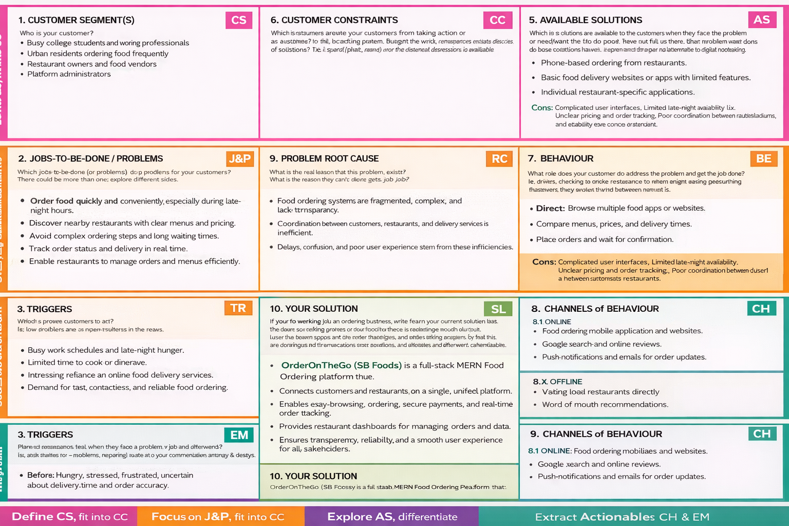

**Problem–Solution Fit Template – OrderOnTheGo (SB Foods)**

**1. CUSTOMER SEGMENT(S)**

• Busy college students and working professionals  
• Urban residents ordering food frequently  
• Restaurant owners and food vendors  
• Platform administrators

**2. JOBS-TO-BE-DONE / PROBLEMS**

• Order food quickly and conveniently, especially during late-night hours.  
• Discover nearby restaurants with clear menus and pricing.  
• Avoid complex ordering steps and long waiting times.  
• Track order status and delivery in real time.  
• Enable restaurants to manage orders and menus efficiently.

**3. TRIGGERS**

• Busy work schedules and late-night hunger.  
• Limited time to cook or dine out.  
• Increasing reliance on online food delivery services.  
• Demand for fast, contactless, and reliable food ordering.

**4. EMOTIONS: BEFORE / AFTER**

Before: Hungry, stressed, frustrated, uncertain about delivery time and order accuracy.  
After: Satisfied, relaxed, confident, and comfortable with a smooth ordering experience**.**

**5. AVAILABLE SOLUTIONS**

• Phone-based ordering from restaurants.  
• Basic food delivery websites or apps with limited features.  
• Individual restaurant-specific applications.

Cons:  
• Complicated user interfaces  
• Limited late-night availability• Unclear pricing and order tracking  
• Poor coordination between customers and restaurants

**6. CUSTOMER CONSTRAINTS**

• Budget sensitivity and delivery charges.  
• Trust concerns regarding online payments.  
• Inconsistent food quality and delivery delays.  
• Limited technical awareness among some users.

**7. BEHAVIOUR**

**Direct:**• Browse multiple food apps or websites.  
• Compare menus, prices, and delivery times.  
• Place orders and wait for confirmation.

Indirect:  
• Ask friends for restaurant recommendations.  
• Read online reviews and ratings.

**8. CHANNELS OF BEHAVIOUR**

**8.1 ONLINE**

• Food ordering mobile applications and websites.  
• Google search and online reviews.  
• Push notifications **and emails for order updates.**

**8.2 OFFLINE**

• Visiting local restaurants directly.  
• Word-of-mouth recommendations.

**9. PROBLEM ROOT CAUSE**

Food ordering systems are often fragmented, complex, and lack transparency. The core issue lies in inefficient coordination between customers, restaurants, and delivery services, leading to delays, confusion, and poor user experience.

**10. YOUR SOLUTION**

OrderOnTheGo (SB Foods) is a full-stack MERN-based food ordering platform that:  
• Connects customers and restaurants on a single unified platform.  
• Enables easy browsing, ordering, secure payments, and real-time order tracking.  
• Provides restaurant dashboards for efficient order and menu management.  
• Ensures transparency, reliability, and a smooth user experience for all stakeholders.